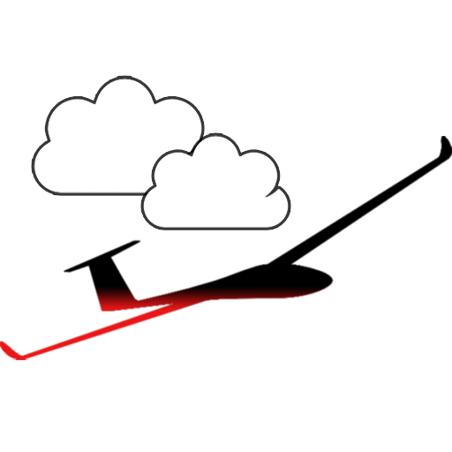

# 

# Sailplane Launch

HELP FILE

v. 1.0  
19.03.2014

## Introduction

1. Installation

## Usage

1. Contact